Segger J-Link
- Download and install J-Link Software and Documentation pack
  - https://www.segger.com/downloads/jlink/

nRF Command Line Tools
- Download and install nRF Command Line Tools
  - https://www.nordicsemi.com/Products/Development-tools/nRF-Command-Line-Tools/Download

nRF Utils
- Download and install nRF Utils
  - https://www.nordicsemi.com/Products/Development-tools/nRF-Util/Download#infotabs
- Create the following folder:
  - C:\nrf\utils
  - Move the downloaded nrfutil.exe into C:\nrf\utils
- Add C:\nrf\utils to your PATH in Environment Variables
- Open up command prompt
- Run the following command to install the SDK tools
  - nrfutil install nrf5sdk-tools

VS Code
- Download and install VS Code: https://code.visualstudio.com/.

nRF Connect
- Open VS Code.
- Go to the Extensions (left pane) view
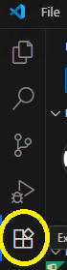
- Search for nRF Connect for VS Code Extension Pack and install it.
  - When prompted, select Trust Publisher and Install

nRF Connect SDK and Toolchain:
- After installing the extension, a new nRF Connect icon on the left pane should appear. Open the nRF Connect view.
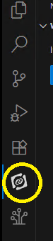
  - You might be prompted about discontinued toolchains. If so, select OK, do not show again.
- In the nRF Connect View, click on Install Toolchain
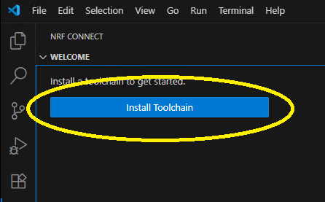
- Wait for tools to fetch available toolchains, then select v2.8.0.
  - This install will take some time. Status will be shown in the bottom right corner.
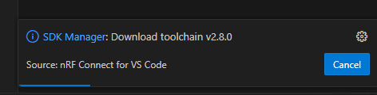

SDK:
- After the toolchain is installed, back in the nRF Connect view, click on Manage SDK
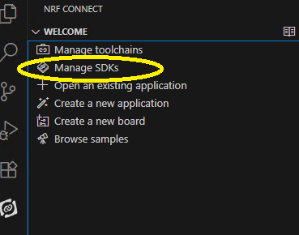
- A dropdown will pop up, select Install SDK
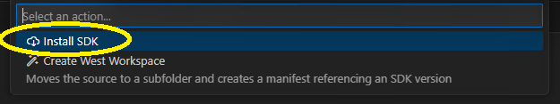
- Choose v2.8.0, make sure the location is C:\ncs\v2.8.0 and hit enter to install the SDK.
  - This will also take some time.

Application:
- Go back to VS Code at the nRF Connect view and select Create a new application
  - When prompted, select Create a blank application
  - In the project location, enter C:\ncs\apps\cyber_scope, and hit enter.
  - A window will pop up indicating the new application has been created. Click Open.
    - If prompted, check the Trust the authors box and click on Yes, I trust the authors.
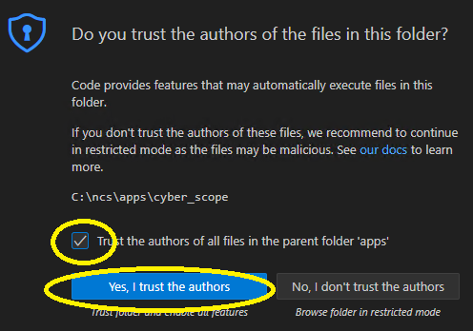
- In file explorer, navigate to C:\ncs\apps\cyber_scope and check out the following from SVN:
  - https://maps110/svn/svnMAPS/trunk/projCyber/scope/sw
  - C:\ncs\apps\cyber_scope
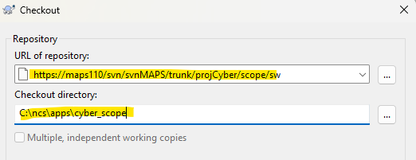

Adding Boards:
- Next, in VS Code, go to File > Preferences > Settings.
  - In the search box, type board
  - Click on Add Item, enter C:\ncs\boards and click Ok.
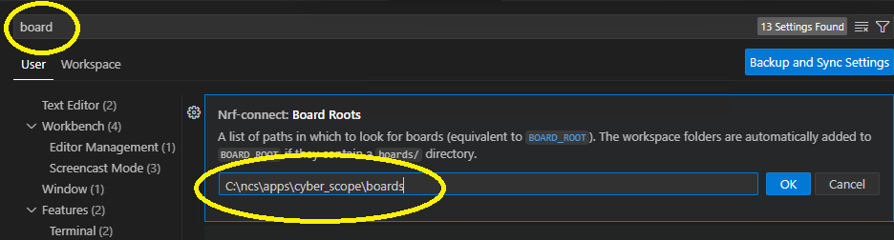
- You can now close out of settings.

Building:
- In the nRF Connect view, click on + Add build configuration under Applications.
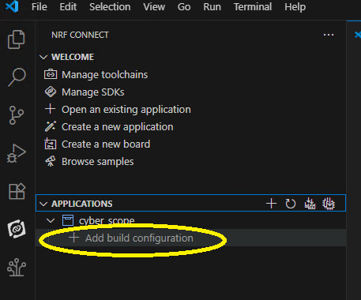
- Select the following, then click Generate and Build
